

**WEB TECHNOLOGY LAB- 4.5CA152C01**

**MANAV RACHNA INTERNATIONAL INSTITUTE OF RESEARCH AND STUDIES**

**SCHOOL OF COMPUTER APPLICATION**

|  |  |
| --- | --- |
| ***SUBMITTED BY*** |  |
| **Student Name** | **Priyansha Asthana** |
| **Roll no.** | **24/SCA/BCA(AI&ML)/053** |
| **Programme** | **BCA** |
| **Semester** | **1** |
| **Section/Group** | **B / GROUP-2** |
| **Department** | **SCA** |
| **Session/ Batch** | **2024-2028** |
| **SUBMITTED TO** |  |
| **Faculty Name** | **Mrs. Sakshi** |

**SCHOOL OF COMPUTER APPLICATION**

**INDEX**

|  |  |  |
| --- | --- | --- |
| **S.No** | **Experiment** | **Remark** |
|  | **Create a simple HTML page using basic tags.** |  |
|  | **Create a web page that displays your name to the screen.** |  |
|  | **Create a web page and show the output from 1 to 10 in separate lines.** |  |
|  | **Create a web page and show the output from 1 to 10 in separate lines, each number being in different color.** |  |
|  | **How do I make a picture as a background on my web pages?** |  |
|  | **Create a web page to print a paragraph with 4-5 sentences, each sentence shall have a different font.** |  |
|  | **Write HTML code to print a paragraph that is description of a book, it shall include the title of the book, its author name; name and title should be underlined and all adjectives shall be bold and Italics.** |  |
|  | **Write HTML code to print your name using Heading tag, every letter shall be of different heading size.** |  |
|  | **Write HTML code to print the sequence of numbers 1-20. Each number shall be in different line with number 2 next to it as subscript, an equal sign and the result.** |  |
|  | **Write HTML code to display an image with border of size with width 200, height 200 pixels, leaving Hspace and Vspace of your choice with image hanging in the right side on the screen.** |  |
|  | **Write HTML code to create a web page with heading. The heading shall be displayed at the top-center of the page and the image shall be at the centre, just below the heading.** |  |
|  | **Write HTML code using Multimedia tags.** |  |
|  | **Create a Table using Rowspan and Colspan taking example of student Record.** |  |
|  | **Write HTML code using table tag <table> and cellpadding and cell spacing as its attributes.** |  |
|  | **Create unordered, ordered and definition Lists taking example of your subjects in MCA IST, IInd and IIIrd Semester.** |  |
|  | **Write HTML code using <frameset> and <frame> tag with all its attributes** |  |
|  | **Write HTML code to design a form in HTML using controls and buttons such as Textbox, Text area, password, submit button, browse button, drop-down menu** |  |
|  | **Write HTML code to design a Registration Form in HTML.** |  |
|  | **Write HTML code to design a student admission Form in HTML.** |  |
|  | **Create a proper home page of your own using any components and styles.** |  |
|  | **Write HTML code for including Local hyperlinking in a web page.** |  |
|  | **Write HTML code for including Inter hyperlinking in a web page.** |  |
|  | **Write HTML code for including External hyperlinking in a web page.** |  |
|  | **Write code to show External CSS with HTML code** |  |
|  | **Write code to show Internal CSS with HTML code.** |  |
|  | **Write code to show Inline CSS with HTML code.** |  |
|  | **Write a program to add two numbers using form in JavaScript.** |  |
|  | **Write a program in JavaScript to swap two images using on mouseover event.** |  |
|  | **Write a simple JavaScript program to sort an array** |  |
|  | **Write a JavaScript program to take as input three numbers from the user. Find the minimum and maximum of the three numbers. Print the following output in BOLD in the following format:**  **MINIMUM =        MAXIMUM =** |  |

Q1. Create a simple html using basic tags.

INPUT:-

<html>

<head><title>My first page </title>

</head>

<body>Sport is a form of physical acitivity or game, often competitive and organized,

Sports use, maintain, or improve physical ability and skills.

</body>

</html>

OUTPUT:-

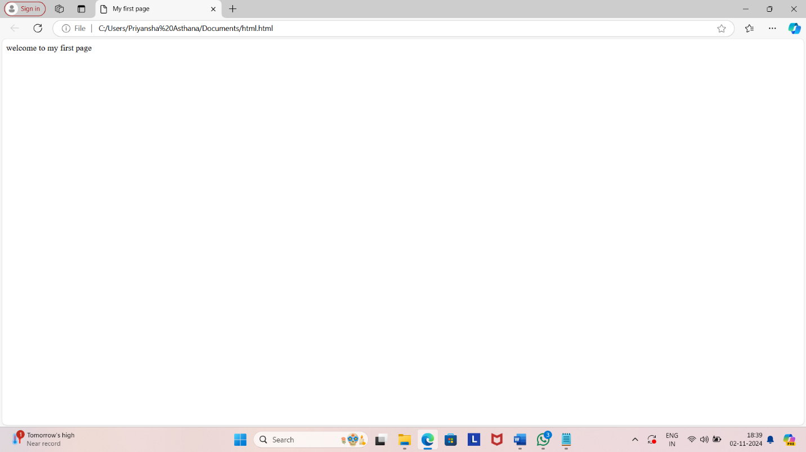

Q2. Create web page that displays your name on screen.

INPUT:-

<html>

<head><title>My first page </title>

</head>

<body>PRIYANSHA </body>

</html>

OUTPUT:-

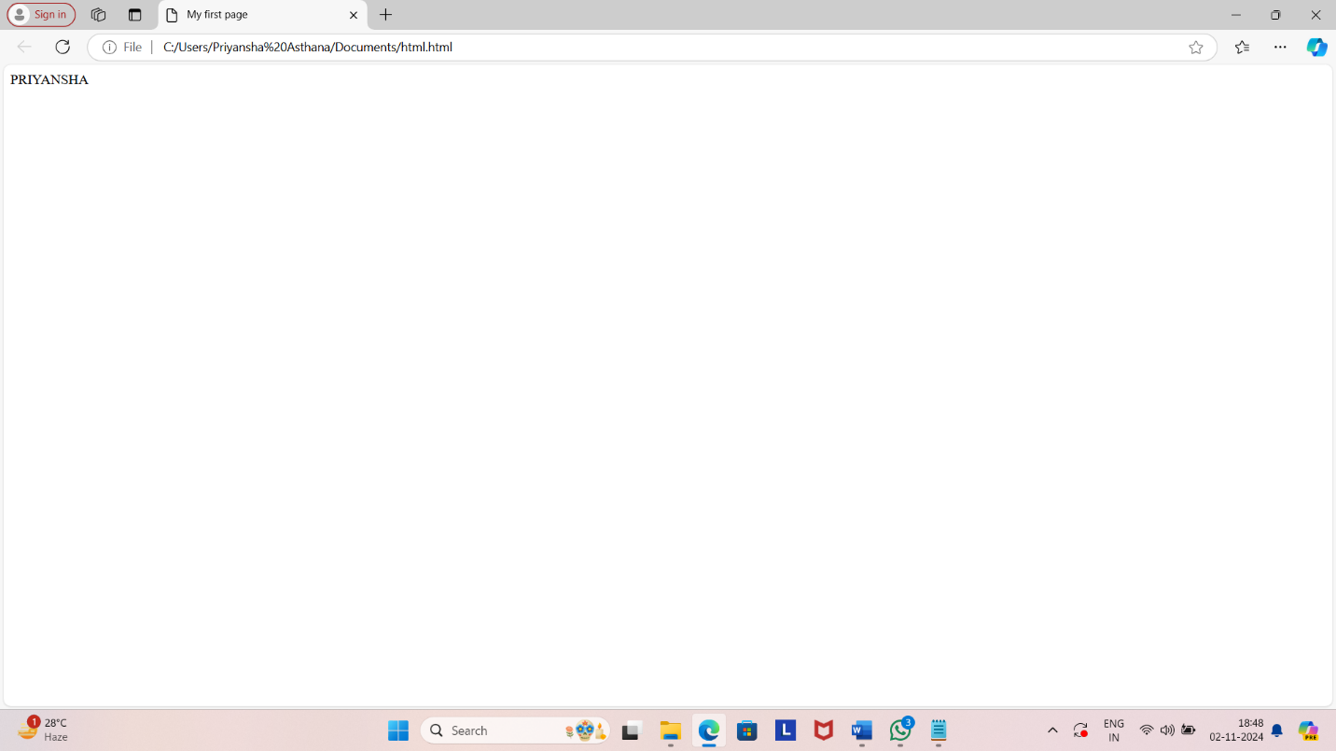

Q3. Create a web page and show the output from 1 to 10 in separate lines.

INPUT:-

<html>

<head><title>My first page </title>

</head>

<body> 1<br>2<br>3<br>4<br>5<br>6<br>7<br>8<br>9<br>10</body>

</html>

OUTPUT:-

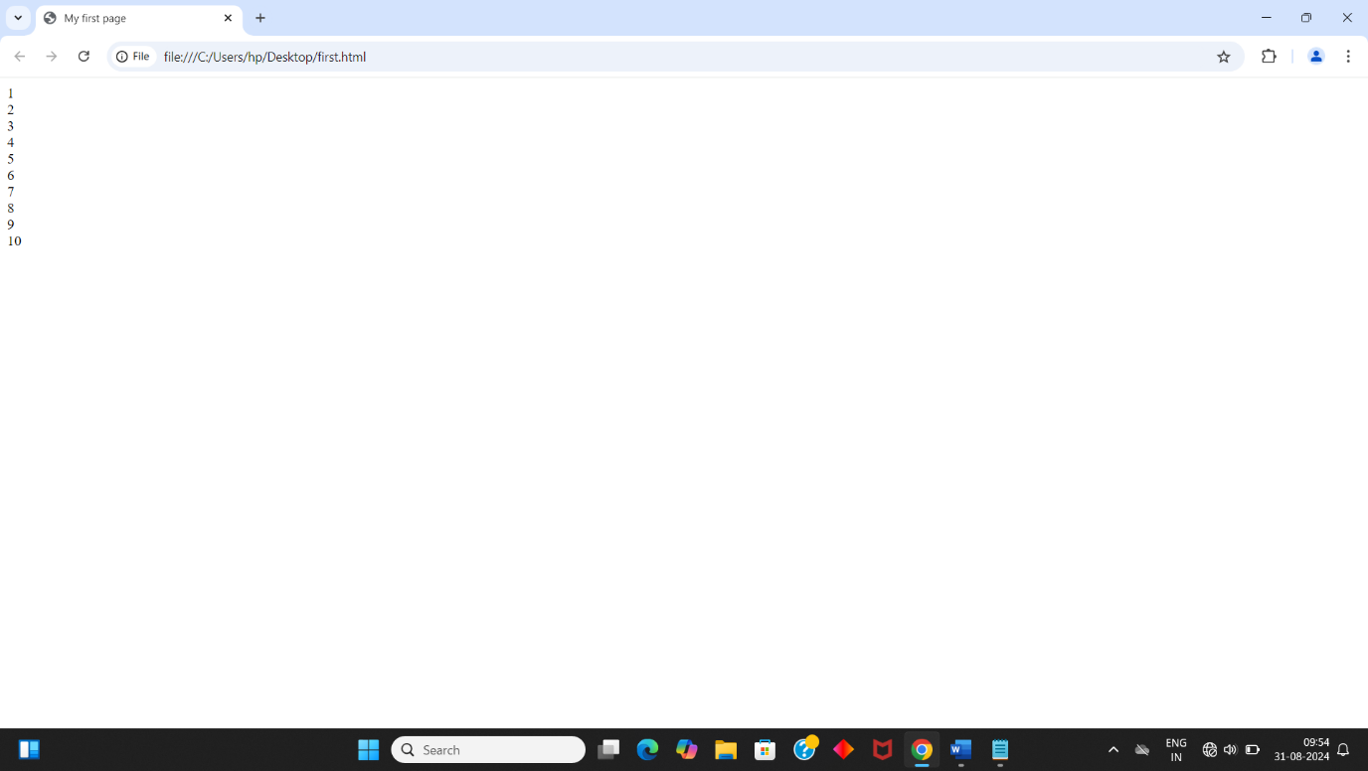

Q4. Create a web page and show the output from 1 to 10 in separate lines, each number being in different color.

INPUT:-

<html>

<head><title>My first page </title>

</head>

<body> 1<br><font color='red'>2<br><font color='green'>3<br><font color='blue'>4<br><font color='orange'>5<br><font color='pink'>6<br><font color='brown'>7<br><font color='yellow'>8<br><font color='cyan'>9<br><font color='purple'>10</body>

</html>

OUTPUT:-

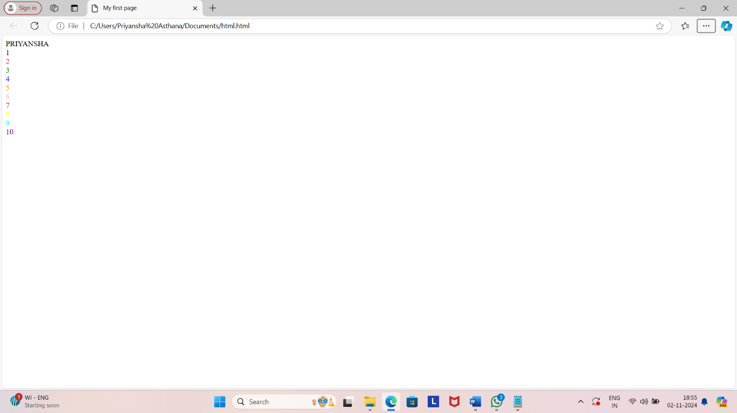

Q5. How do I make a picture as a background on my web pages?

INPUT:-

<html>

<head><title>My first page </title>

</head>

<body background="https://cdn.britannica.com/48/252748-050-C514EFDB/Virat-Kohli-India-celebrates-50th-century-Cricket-November-15-2023.jpg"> 1<br><font color='red'>2<br><font color='green'>3<br><font color='blue'>4<br><font color='orange'>5<br><font color='pink'>6<br><font color='brown'>7<br><font color='yellow'>8<br><font color='cyan'>9<br><font color='purple'>10</body>

</html>

OUTPUT:-

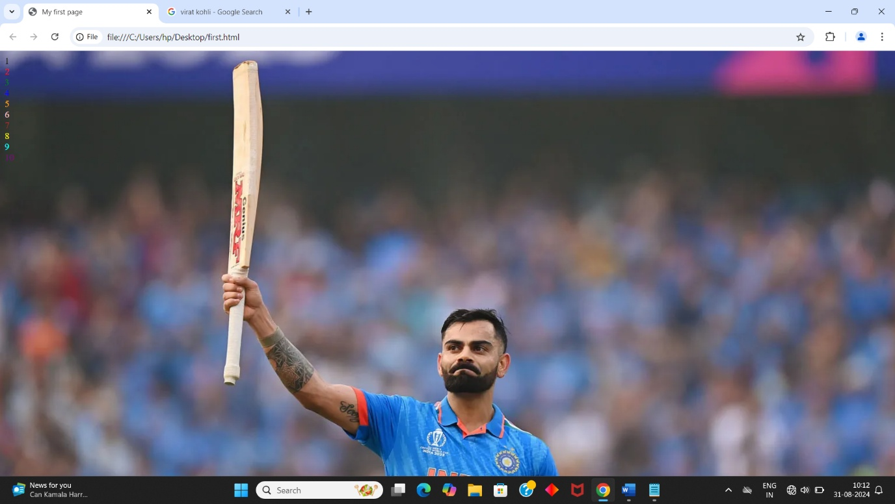

Q6. Create a web page to print a paragraph with 4-5 sentences, each sentence shall have a different font.

Input:

<html>

<head><title>My first page </title>

</head>

<body><font face="arial">Book Fairs are held every year in Delhi.<br></font>

<font face="georgia">The site is the Pragati Maidan. Here is an exhibition of thousands of books under one roof. You can buy books on all subjects and topics. <br></font>

<font face="impact">The fair attracts millions of people from far and near. Hundreds of stalls are put up by Indian and foreign <br></font>

<font face="courier">publishers. It is a great attraction for book lovers and scholars. </font>

<font face="gill sans"> It should not be missed. </font>

</body>

</html>

OUTPUT:-

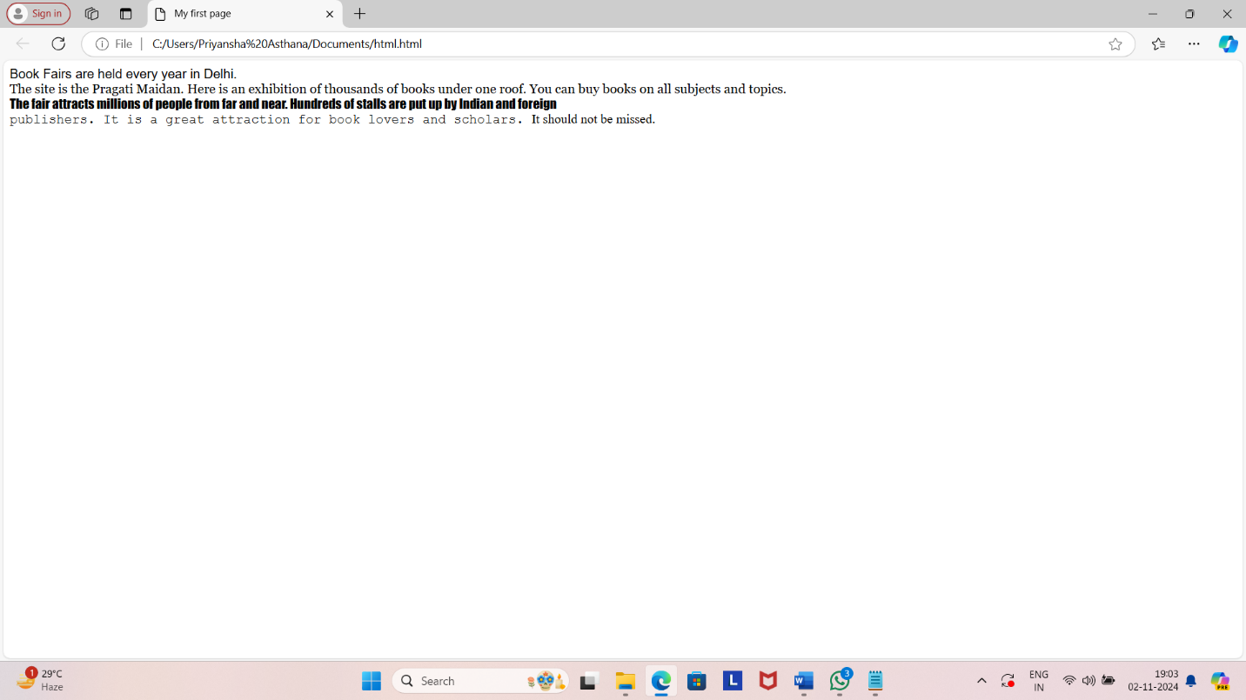

Q7. Write HTML code to print a paragraph that is description of a book, it shall include the title should be underlined and all adjectives shall be bold and italics.

INPUT:-

<html>

<head>

<title>

Description

</title>

</head>

<body>

<center><h1>DRACULA</h1></center>

<br>

<h2><b><i>BRAM STOKER </i></b></h2>

<br>

Dracula is a gothic horror novel by Bram Stoker, published on 26 May 1897. An epistolary novel, the narrative is related through letters, diary entries, and newspaper articles. It has no single protagonist and opens with solicitor Jonathan Harker taking a business trip to stay at the castle of a Transylvanian nobleman, Count Dracula. Harker escapes the castle after discovering that Dracula is a vampire, and the Count moves to England and plagues the seaside town of Whitby.

- <u> DRACULA </u> WAS MY FAVOURITE CHARACTER AND <u> VAMPIRE </u> WAS <b> <u> AMAZING </b> </u>.

</body>

</html>

OUTPUT:-

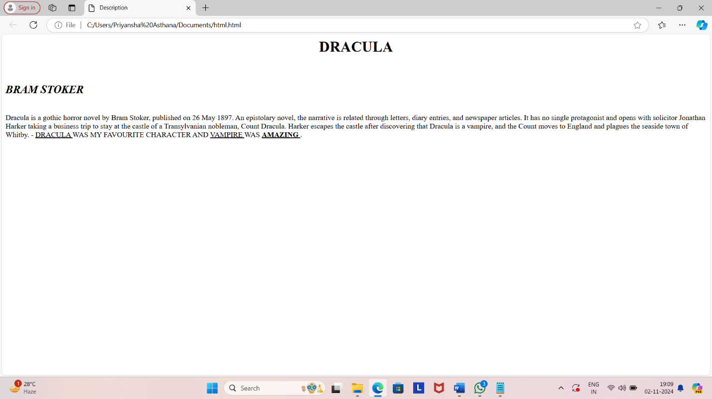

Q8. Write HTML code to print your name using Heading tag, every letter shall be of different heading size.

INPUT:-

<html>

<head>

</head>

<body>

<h1>P</h1><H2>R</H2><H3>I</H3><H4>Y</H4><H5>A</H5><H6>A</H6>

</body>

</html>

OUTPUT:-

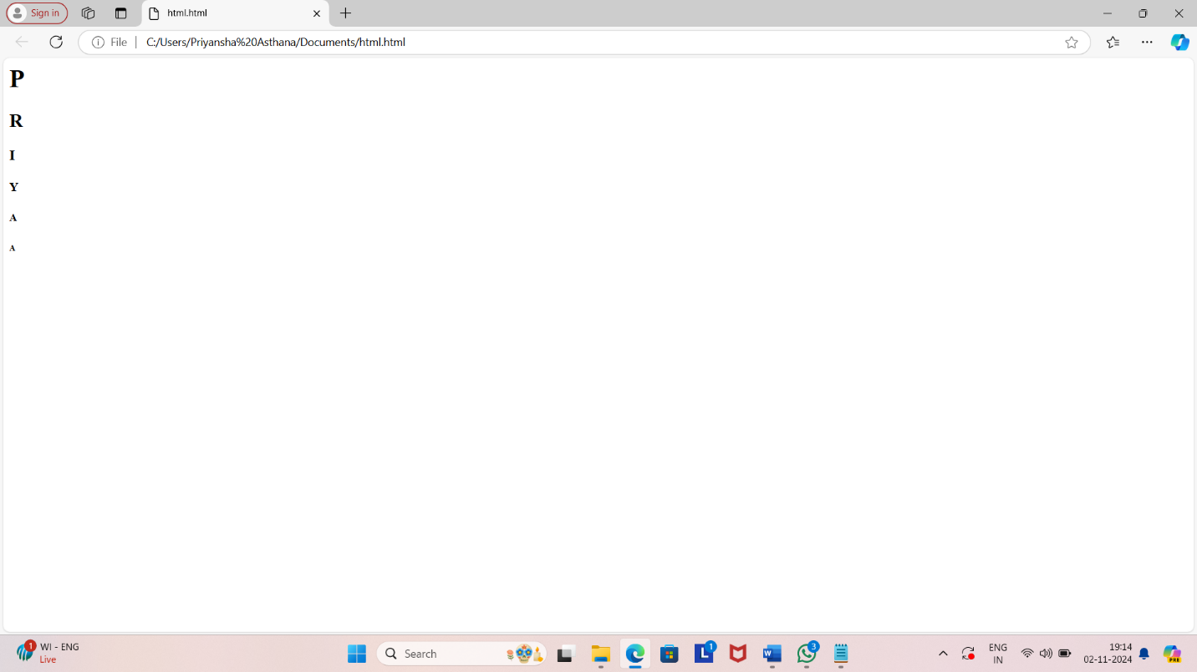

Q9. Write HTML code to print the sequence of numbers 1 – 20. Each number shall be in different line with number 2 next to it as subscript, an equal sign and the result.

INPUT:-

<html>

<head>

<title> number sequence</title>

</head>

<body>

<p>1<sub>2</sub> = 1</p>

<p>2<sub>2</sub> = 4</p>

<p>3<sub>2</sub> = 9</p>

<p>4<sub>2</sub> = 16</p>

<p>5<sub>2</sub> = 25</p>

<p>6<sub>2</sub> = 36</p>

<p>7<sub>2</sub> = 49</p>

<p>8<sub>2</sub> = 64</p>

<p>9<sub>2</sub> = 81</p>

<p>10<sub>2</sub> = 100</p>

<p>11<sub>2</sub> = 121</p>

<p>12<sub>2</sub> = 144</p>

<p>13<sub>2</sub> = 169</p>

<p>14<sub>2</sub> = 196</p>

<p>15<sub>2</sub> = 225</p>

<p>16<sub>2</sub> = 256</p>

<p>17<sub>2</sub> = 289</p>

<p>18<sub>2</sub> = 324</p>

<p>19<sub>2</sub> = 361</p>

<p>20<sub>2</sub> = 400</p>

</body>

</html>

OUTPUT:-

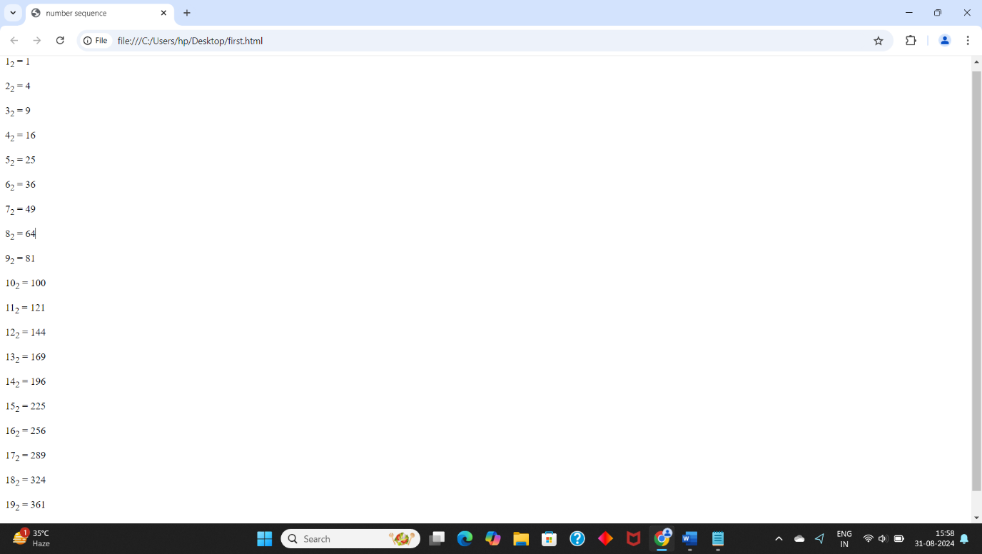

Q10. Write html code to display an image with border of size with width 200, height 200 pixels, leaving Hspace and Vspace of your choice with image handing in the right side on the screen.

INPUT:-

<html>

<body>

<RIGHT><img src ="https://im.rediff.com/cricket/2023/jan/17kohli1.jpg"height="200"width="200"></RIGHT></body>

</html>

OUTPUT:-

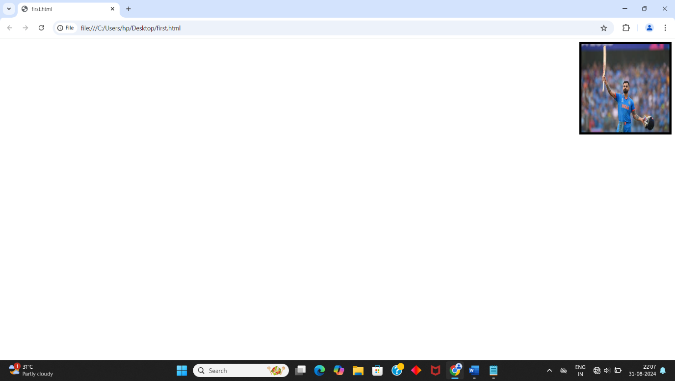

Q11. Write HTML code to create a web page with heading. The heading shall be displayed at the top-center of the page and the image shall be at the centre, just below the heading.

INPUT:-

<html>

<head>web page </head>

<body>

<center><h1>VIRAT KOHLI</h1></center>

<center><img src ="https://im.rediff.com/cricket/2023/jan/17kohli1.jpg"height="300"width="300"></center></body>

</html>

OUTPUT:-

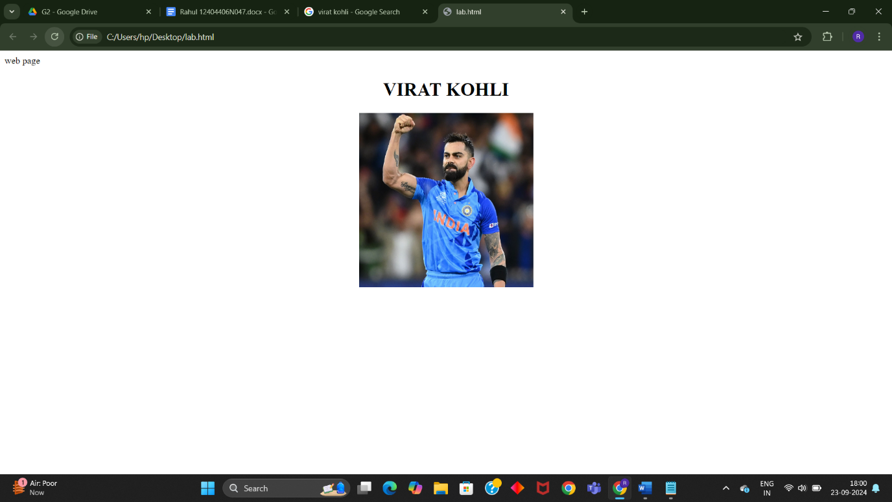

Q12. Write HTML code using Multimedia tags.

FOR VIDEO

<!DOCTYPE html>

<html>

<body>

<video width="400" controls>

<source src="mov_bbb.mp4" type="video/mp4">

<source src="mov_bbb.ogg" type="video/ogg">

</video>

</html>

</body>

FOR AUDIO

<!DOCTYPE html>

<html>

<body>

<audio controls>

<source src="horse.ogg" type="audio/ogg">

<source src="horse.mp3" type="audio/mpeg">

</audio>

</html>

</body>

Q13. Create a Table using Rowspan and Colspan taking example of student Record

INPUT:-

<html>

<head></head>

<body>

<table border='4pt'>

<tr>

<th colspan='2'>Name</th>

<th>class</th>

<th>school</th></tr>

<tr>

<td rowspan='2'>mahatma</td>

<td rowspan='2'>gandhi</td>

<td> 11</td>

<td>mvps</td></tr>

<tr>

<td>A</td></tr>

<tr>

<td rowspan='2'>shree</td>

<td rowspan='2'>krishna</td>

<td> 3</td>

<td>nvps</td></tr>

<tr>

<td>B</td></tr>

<tr>

OUTPUT:-

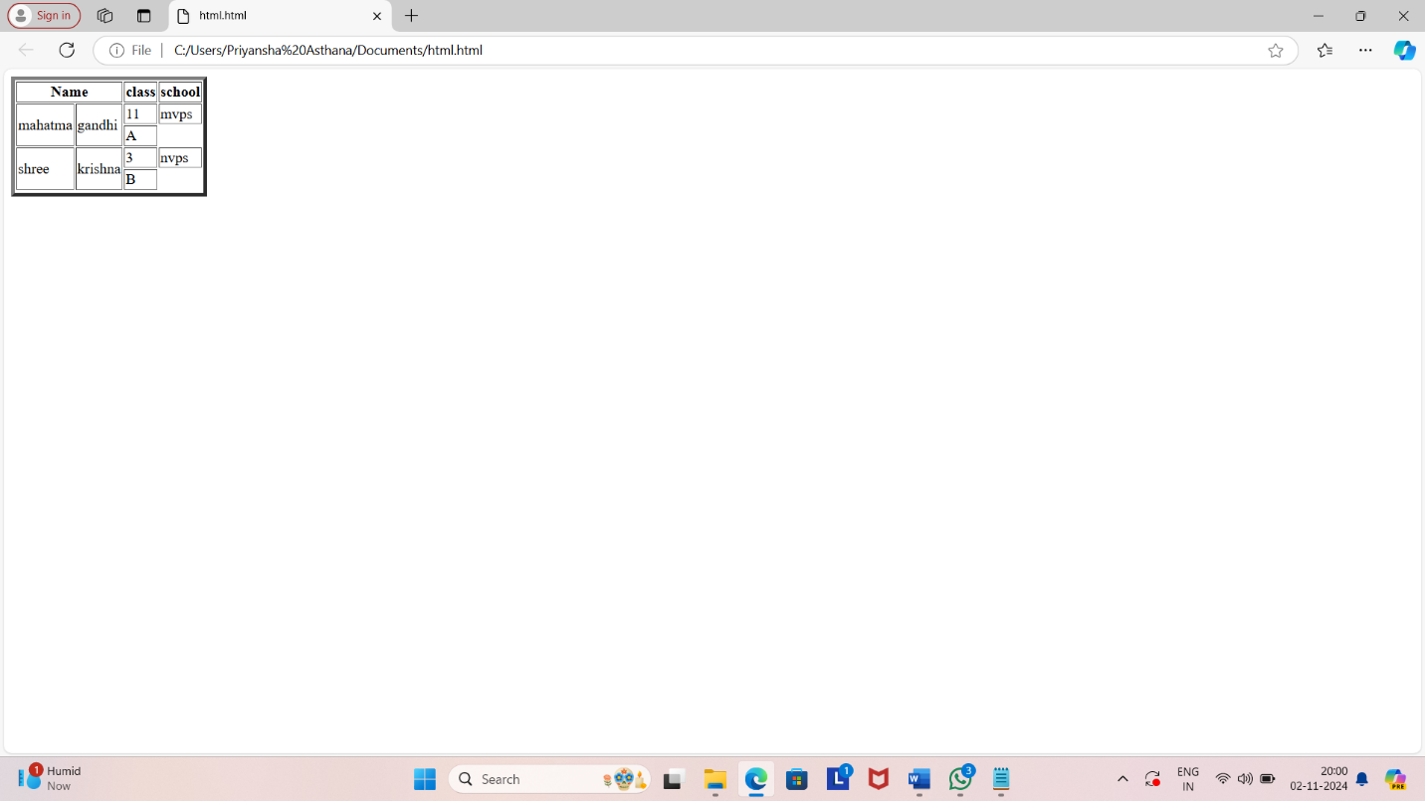

Q14.Write HTML code using table tag <table> and cellpadding and cell spacing as its attributes.

INPUT:-

<html>

<head></head>

<body>

<table border="2pt" cellspacing="5pt" cellpadding="5pt">

<tr>

<th>S.no</th>

<th>Roll no.</th>

<th>Name</th>

<th>Address</th></tr>

<tr>

<td>1</td>

<td>123</td>

<td>ABC</td>

<td>FBD</td></tr>

<tr>

<td>2</td>

<td>456</td>

<td>XYZ</td>

<td>delhi</td></tr>

<tr>

<td>3</td>

<td>789</td>

<td>PQR</td>

<td>gurgaon</td></tr>

</table></body>

</html>

OUTPUT:-

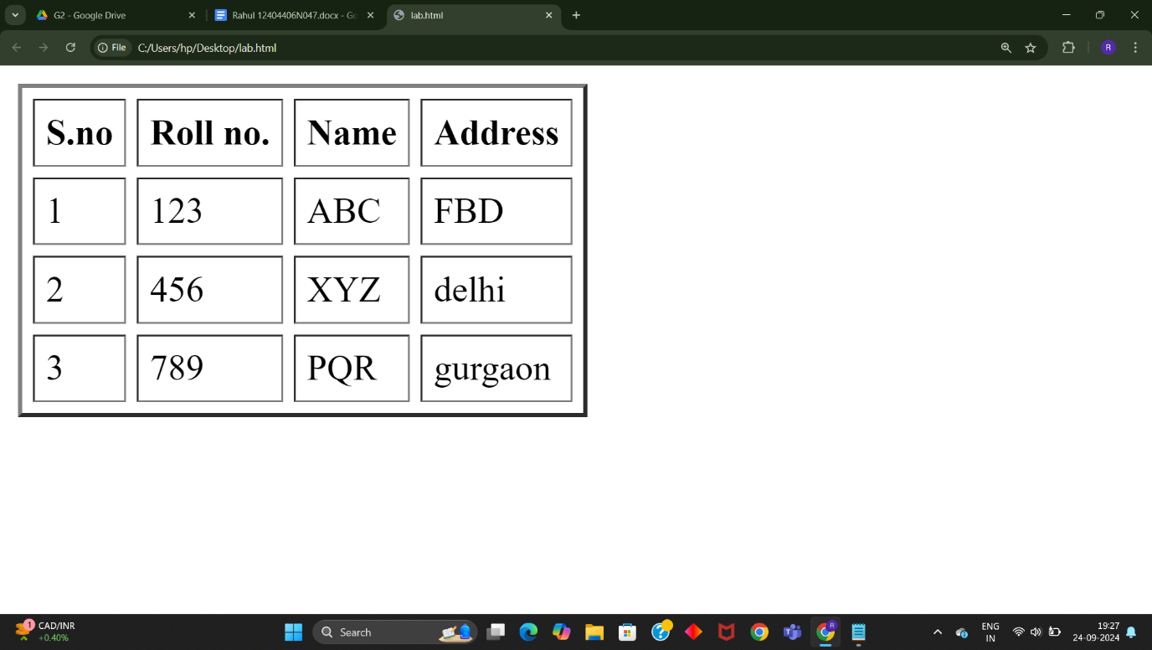

Q15. Create unordered, ordered and definition Lists taking example of your subjects in MCA IST, IInd and IIIrd Semester.

INPUT :-

<html>

<head></head>

<body>

<h3> Subjects in BCA sem 1</h3>

<ol>

<li>Web technologies</li>

<ul>

<li>introduction to Networks</li>

<li>introduction to e-mail</li>

<li>introduction to html</li>

</ul>

<li>Introduction to IT & programming in C</li>

<ul>

<li>Input output devices</li>

<li>compilers,Interpreters,assemblers</li>

<li>various programs in C</li>

</ul>

<li>Mathematics</li>

<ul>

<li>matrices</li>

<li>surds and insurdes</li>

<li>trigonometry</li><ul><ol>

</body>

</html>

OUTPUT:-

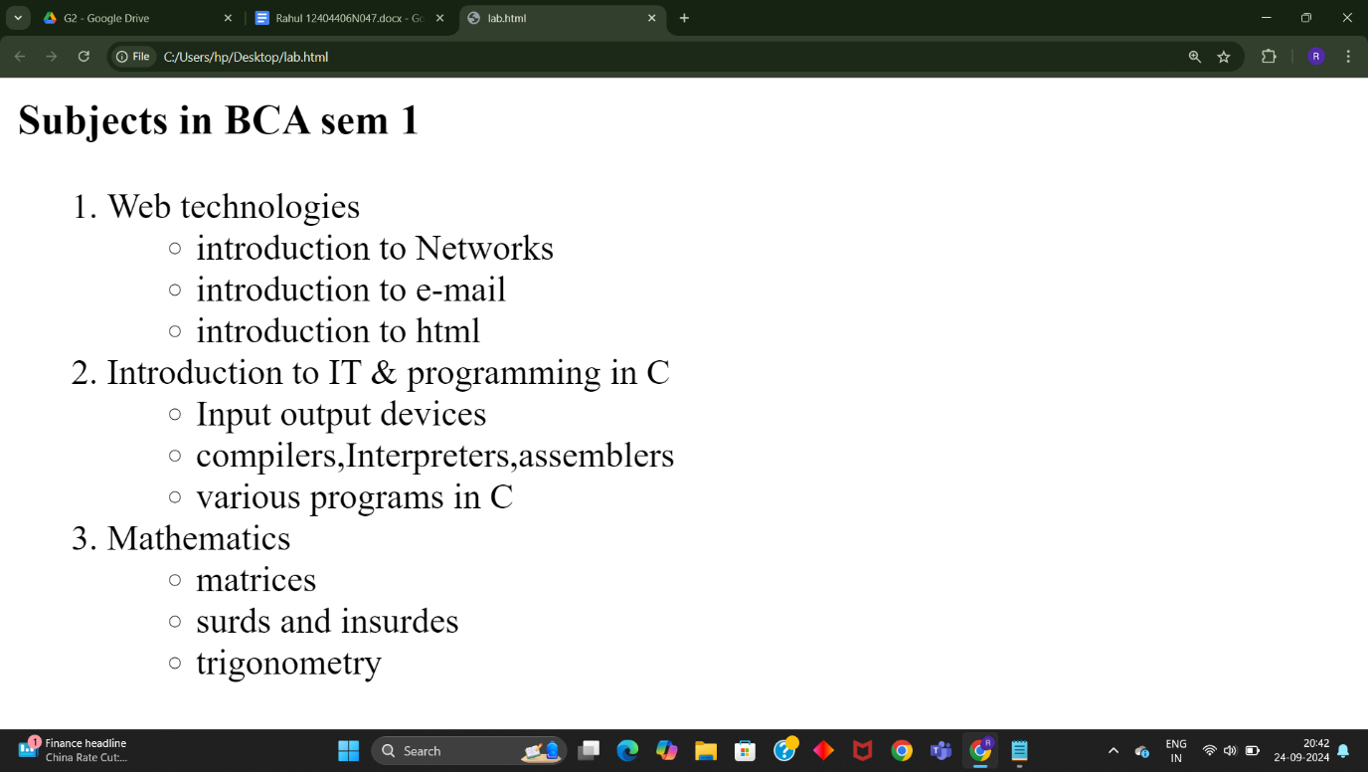

Q16. Write HTML code using <frameset> and <frame> tag with all its attributes.

INPUT:-

<!DOCTYPE html>

<html>

<head>

<title>Frameset Example</title>

</head>

<frameset cols="30%,50%,20%">

<frame src="frame1.html" name="frame1" scrolling="yes" noresize="noresize" frameborder="1" marginwidth="10" marginheight="10">

<frame src="frame2.html" name="frame2" scrolling="auto" noresize="noresize" frameborder="1" marginwidth="10" marginheight="10">

<frame src="frame3.html" name="frame3" scrolling="no" noresize="noresize" frameborder="1" marginwidth="10" marginheight="10">

</frameset>

<body>

</body>

</html>

OUTPUT:-

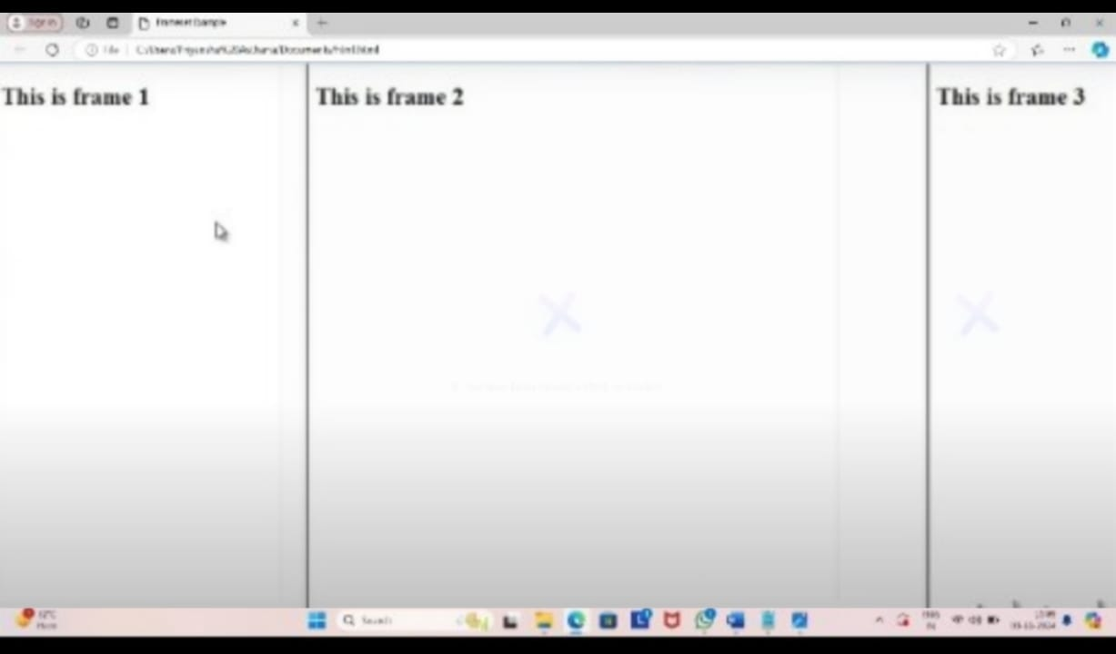

Q17. Write HTML code to design a form in HTML using controls and buttons such as Textbox, Text area, password, submit button, browse button, drop-down menu.

INPUT:-

<!DOCTYPE html>

<html>

<body>

<h2>HTML Forms</h2>

<form action="backend.php">

<label for="fname">First name:</label><br>

<input type="text" id="fname" name="fname"><br>

<label for="lname">Last name:</label><br>

<input type="text" id="lname" name="lname"><br>

<label for="course">Choose a course:</label>

<select id="course" name="course">

<option value="bca">bca</option>

<option value="mca">mca</option>

<option value="bba ">bba </option>

<option value="mba">mba </option>

</select><br>

<label for="username">Username:</label><br>

<input type="text" id="username" name="username"><br>

<label for="pwd">Password:</label><br>

<input type="password" id="pwd" name="pwd"><br>

Any suggestions:-

<textarea name="message" rows="10" cols="30"></textarea>

<br><br>

<input type="submit" value="Submit">

</form>

</body>

</html>

OUTPUT:-

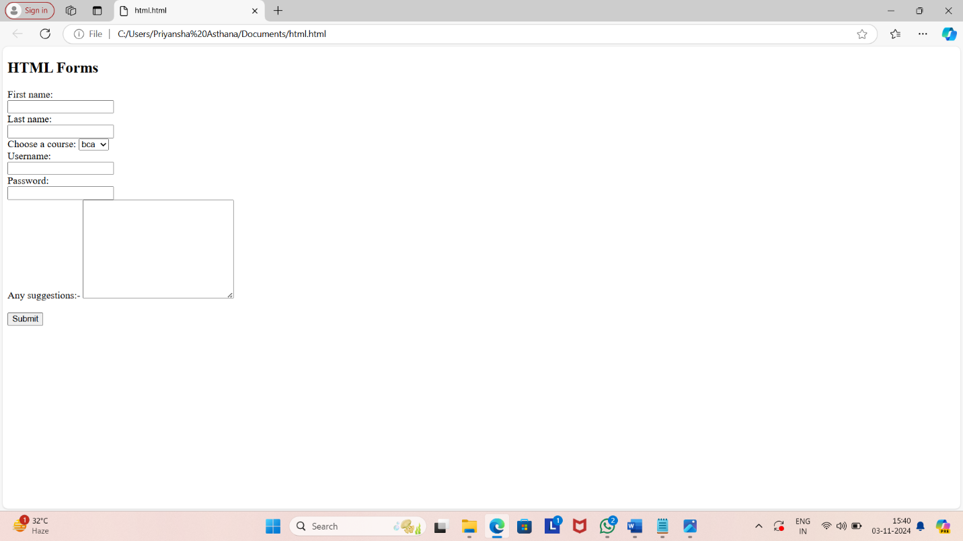

Q18.Write HTML code to design a Registration Form in HTML.

INPUT:-

<!DOCTYPE html>

<html>

<body>

<h1 align=center>Registration form</h1>

<form action="backend.php">

<label for="fname">First name:</label><br>

<input type="text" id="fname" name="fname"><br>

<label for="lname">Last name:</label><br>

<input type="text" id="lname" name="lname"><br>

<BR>

Gender:

<input type=”radio” id= “male” name=”gender” value=”male”>

Male

<input type=”radio” id= “female” name=”gender” value=”female”>

Female

<input type=”radio” id= “other” name=”gender” value=”other”>

Other <br>

Hobbies

<input type=”checkbox” id=”hobby1” name=”hobby1” value=”cooking”> cooking<br>

<input type=”checkbox” id=”hobby2” name=”hobby2” value=”dancing”>dancing<br>

<input type=”checkbox” id=”hobby3” name=”hobby3” value=”reading”>reading <br>

<input type=”checkbox” id=”hobby4” name=”hobby4” value=”singing”>singing <br>

<input type=”checkbox” id=”hobby5” name=”hobby5” value=”other”>other <br>

Phone no.

<input type=”tel” id=”phone” name=”phone” ><br>

Address

<input type=”text” size=”50%” id=”address”> <br>

Email

<input type=”email” id=”email” name=”email”><br>

<label for="course">Choose a course:</label>

<select id="course" name="course">

<option value="bca">bca</option>

<option value="mca">mca</option>

<option value="bba ">bba </option>

<option value="mba">mba </option>

</select><br>

Any suggestions:-

<textarea name="message" rows="10" cols="30"></textarea>

<br><br>

<input type="submit" value="Submit">

</form>

</body>

</html>

Q19. Write HTML code to design a student admission Form in HTML.

INPUT:-

<!DOCTYPE html>

<html>

<head>

<title>Student Admission Form</title>

</head>

<body>

<h1>Student Admission Form</h1>

<form action="submit.php" method="post">

<label for="student_name">Student Name</label><br>

<input type="text" id="student_name" name="student_name" required><br><br>

<label for="date_of_birth">Date of Birth</label><br>

<input type="date" id="date_of_birth" name="date_of_birth" required><br><br>

<label

for="gender">Gender</label><br>

<input type="radio" id="male" name="gender" value="male">

<label for="male">Male</label>

<input type="radio" id="female"

name="gender" value="female">

<label for="female">Female</label><br><br>

<label for="address">Address</label><br>

<textarea id="address" name="address"

rows="5" cols="30" required></textarea><br><br>

<label for="phone_number">Phone Number</label><br>

<input type="tel" id="phone_number" name="phone_number" required><br><br>

<label for="email">Email</label><br>

<input type="email" id="email" name="email" required><br><br>

<label for="class">Class</label><br>

<select id="class" name="class" required>

<option value="">Please select</option>

<option value="1">1</option>

<option value="2">2</option>

</select><br><br>

<label for="guardian_name">Guardian Name</label><br>

<input type="text" id="guardian_name" name="guardian_name" required><br><br>

<label for="guardian_contact">Guardian Contact</label><br>

<input type="tel" id="guardian_contact" name="guardian_contact" required><br><br>

<input type="submit" value="Submit">

</form>

</body>

</html>

OUTPUT:-

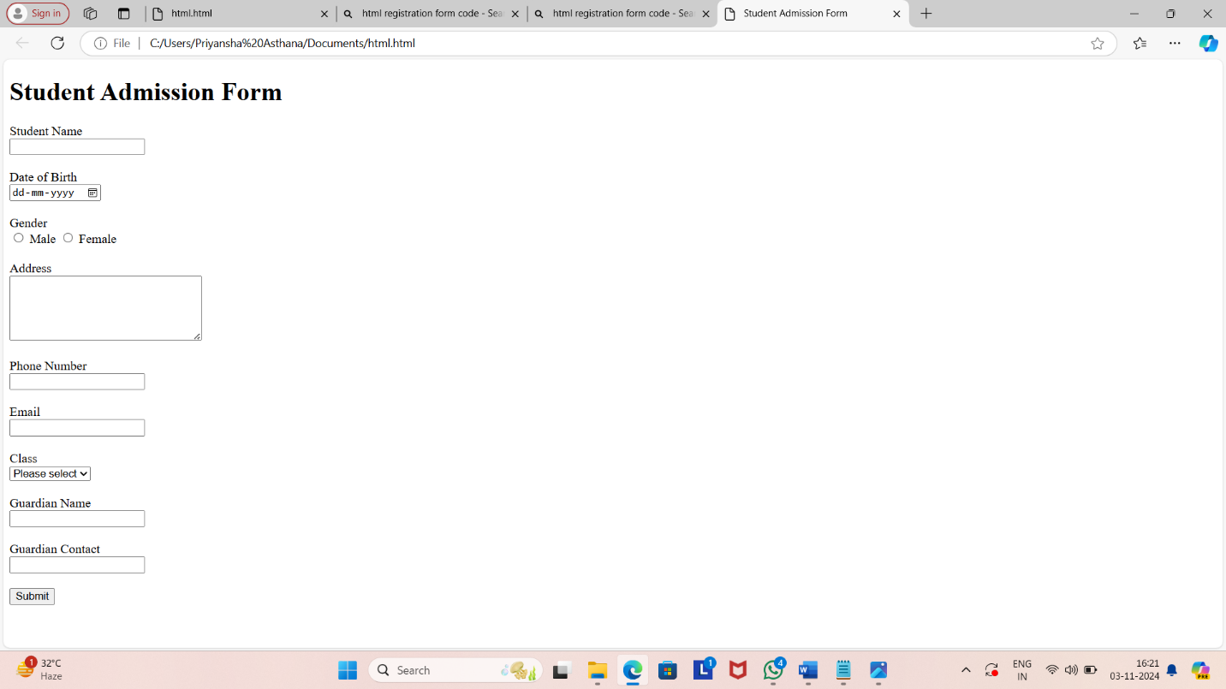

Q20. Create a proper home page of your own using any components and styles.

INPUT:-

<!DOCTYPE html>

<html>

<head>

<title>My Personal Website</title>

<link rel="stylesheet" href="styles.css">

</head>

<body>

<header>

<h1>My Name</h1>

<nav>

<ul>

<li><a href="index.html">Home</a></li>

<li><a href="about.html">About</a></li>

<li><a href="projects.html">Projects</a></li>

<li><a href="contact.html">Contact</a></li>

</ul>

</nav>

</header>

<main>

<section>

<h2>Welcome to My

Website!</h2>

<p>This is a brief introduction about myself. Feel free to explore my projects and contact me.</p>

<img src="profile_pic.jpg" alt="Profile Picture">

</section>

</main>

<footer>

<p>&copy; 2023 My Name</p>

</footer>

</body>

</html>

OUTPUT:-

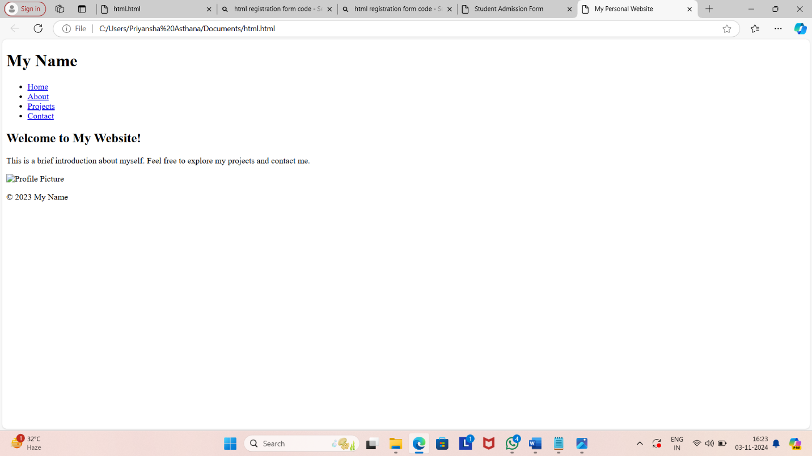

Question-21 Write HTML code for including Local hyperlinking in a web page. **Input:**

<html>

<head>

<title>Local Hyperlinking Example</title>

<style>

body {

font-family: Arial, sans-serif;

margin: 20px;

}

section {

margin-bottom: 40px;

}

</style>

</head>

<body>

<h1>Local Hyperlinking Example</h1>

<ul>

<li><a href="#section1">Go to Section 1</a></li>

<li><a href="#section2">Go to Section 2</a></li>

<li><a href="#section3">Go to Section 3</a></li>

</ul>

<section id="section1">

<h2>Section 1</h2>

<p>This is the content of section 1.</p>

<a href="#top">Back to Top</a>

</section>

<section id="section2">

<h2>Section 2</h2>

<p>This is the content of section 2.</p>

<a href="#top">Back to Top</a>

</section>

<section id="section3">

<h2>Section 3</h2>

<p>This is the content of section 3.</p>

<a href="#top">Back to Top</a>

</section>

</body>

</html>

**Output:**

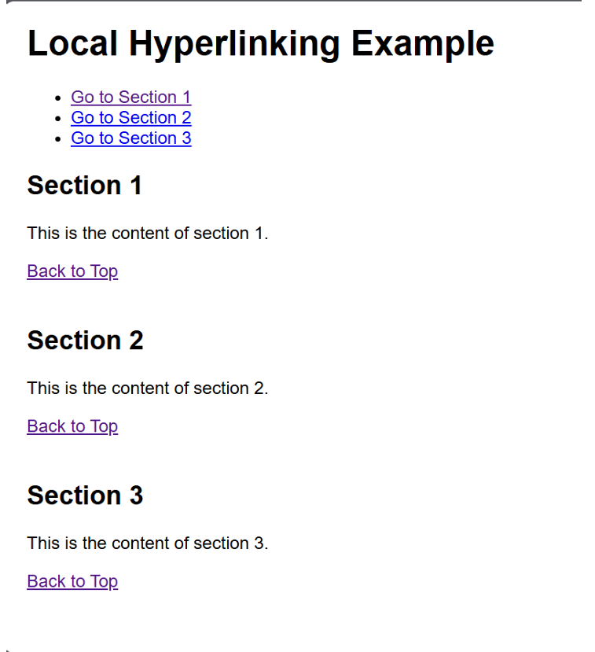

Question-22 Write HTML code for including Inter hyperlinking in a web

page.

**Input:**

<html>

<head>

<title>Interlinking Example</title>

<style>

body {

font-family: Arial, sans-serif;

}

section {

margin: 20px 0;

}

nav {

margin-bottom: 20px;

}

</style>

</head>

<body>

<nav>

<ul>

<li><a href="#section1">Go to Section 1</a></li>

<li><a href="#section2">Go to Section 2</a></li>

<li><a href="#section3">Go to Section 3</a></li>

</ul>

</nav>

<section id="section1">

<h2>Section 1</h2>

<p>This is the first section of the page. You can link to

other sections using the navigation above.</p>

<a href="#top">Back to Top</a>

</section>

<section id="section2">

<h2>Section 2</h2>

<p>This is the second section. Use the navigation to jump

to other sections.</p>

<a href="#top">Back to Top</a>

</section>

<section id="section3">

<h2>Section 3</h2>

<p>This is the third section. Don't forget to check out the

other sections!</p>

<a href="#top">Back to Top</a>

</section>

<a id="top"></a>

</body>

</html>

**Output:**

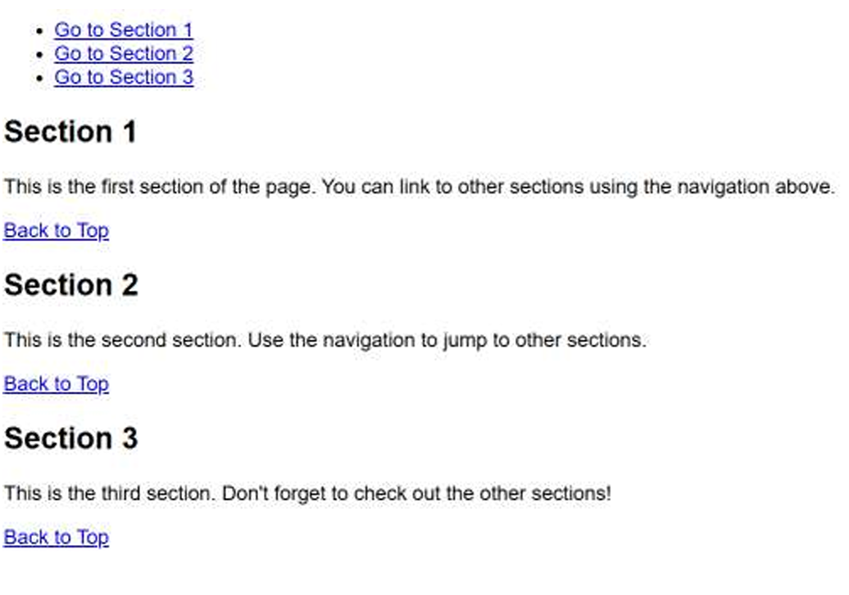

Question-23 Write HTML code for including External hyperlinking in a web page.

**Input:**

<html>

<head>

<title>External Hyperlinking Example</title>

<style>

body {

font-family: Arial, sans-serif;

}

a {

color: blue;

text-decoration: none;

}

a:hover {

text-decoration: underline;

}

</style>

</head>

<body>

<h1>Welcome to My Web Page</h1>

<p>Here are some useful external links:</p>

<ul>

<li><a href="https://www.wikipedia.org" target="_blank"

rel="noopener noreferrer">Visit Wikipedia</a> - A free

online encyclopedia.</li>

<li><a href="https://www.github.com" target="_blank"

rel="noopener noreferrer">Check out GitHub</a> - A

platform for version control and collaboration.</li>

<li><a href="https://www.openai.com" target="_blank"

rel="noopener noreferrer">Learn about OpenAI</a> - An AI

research organization.</li>

</ul>

<p>Feel free to explore the links above!</p>

</body>

</html>

**Output:**

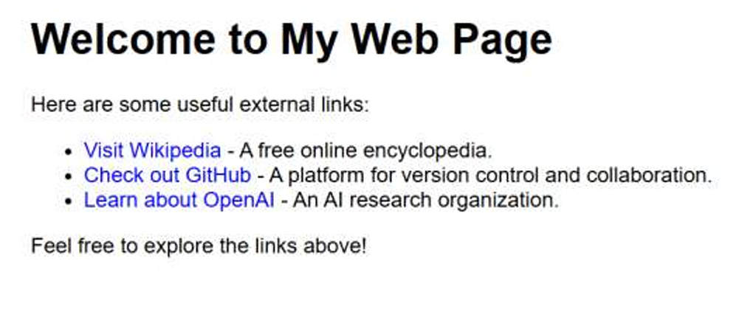

Question-24 Write code to show External CSS with HTML code.

**Input:**

<html>

<head>

<title>External CSS Example</title>

<link rel="stylesheet" href="styles.css"> <!-- Linking

external CSS -->

</head>

<body>

<style>

body {

background-color: #f0f0f0;

font-family: Arial, sans-serif;

}

h1 {

color: #333;

text-align: center;

}

p {

color: #555;

font-size: 18px;

padding: 20px;

}

</style>

<h1>Welcome to My Website</h1>

<p>This is a simple example of using external CSS with

HTML.</p>

</body>

</html>

**Output:**

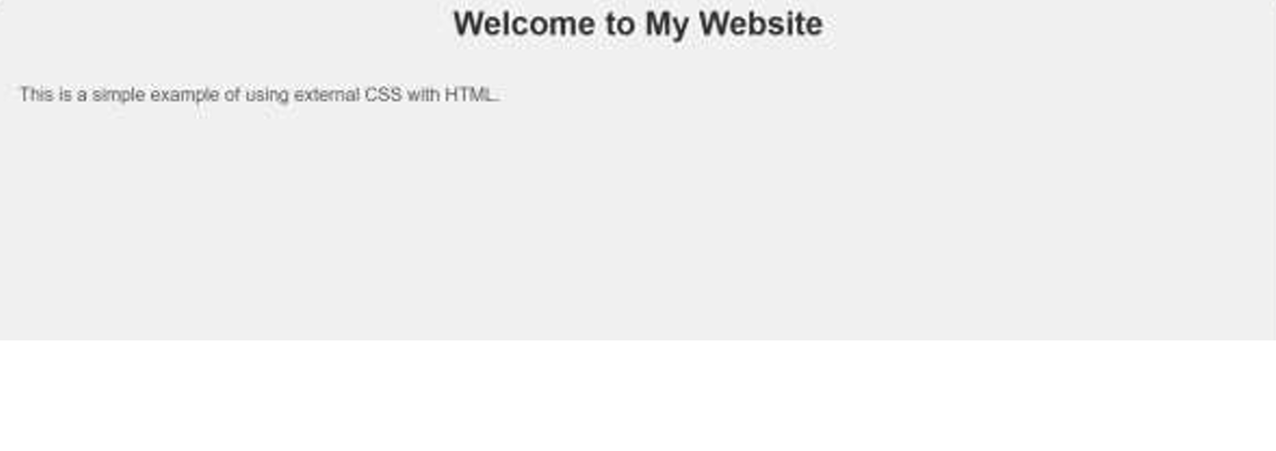

Question-25 Write code to show Internal CSS with HTML code.

**Input:**

<html>

<head>

<title>Internal CSS Example</title>

<style>

body {

background-color:Wite;

font-family: Arial, sans-serif;

}

h1 {

p {

}

}

color:Red;

text-align: center;

color:Blue;

font-size: 18px;

padding: 20px;

</style>

</head>

<body>

<h1>Welcome to My Website</h1>

<p>This is a simple example of using internal CSS with

HTML.</p>

</body>

</html>

**Output:**

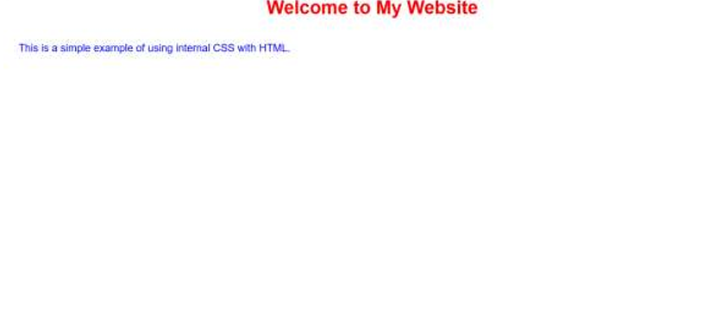

Question-26 Write code to show Inline CSS with HTML code.

**Input:**

<html>

<head>

<title>Inline CSS Example</title>

</head>

<body style="background-color: Black; font-family: Arial,

sans-serif;">

<h1 style="color:White; text-align: center;">Welcome to

My Website</h1>

<p style="color: White; font-size: 25px; padding: 30px;">

This is a simple example of using inline CSS with HTML.

</p>

</body>

</html>

**Output:**

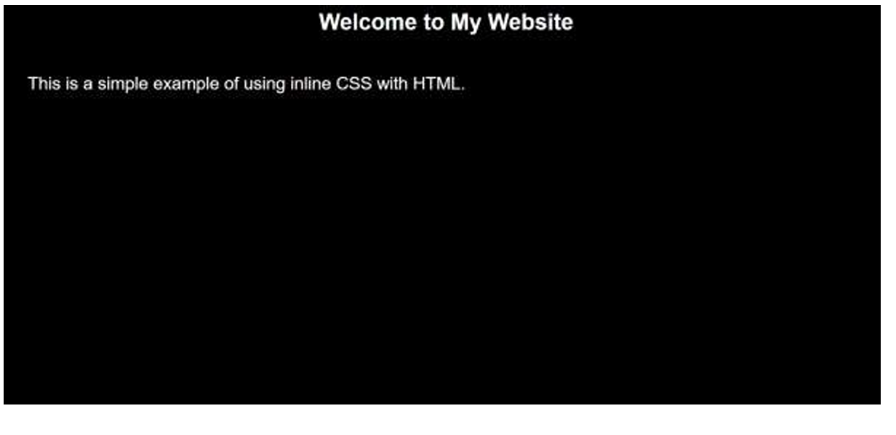

Question-27

Write a program to add two numbers using form in JavaScript.

**Input:**

<html>

<head>

<title>Add Two Numbers</title>

<script>

function addNumbers() {

var num1 = parseFloat(document.getElementById('num1').value);

var num2 = parseFloat(document.getElementById('num2').value);

if (isNaN(num1) || isNaN(num2)) {

alert("Please enter valid numbers.");

} else {

var sum = num1 + num2;

document.getElementById('result').innerHTML = "Result: " + sum;

}

}

</script>

</head>

<body>

<h1>Simple Addition Form</h1>

<!-- Form to input two numbers -->

<form onsubmit="event.preventDefault(); addNumber

<label for="num1">Number 1:</label>

<input type="number" id="num1" required><br><br>

<label for="num2">Number 2:</label>

<input type="number" id="num2" required><br><br>

<button type="submit">Add Numbers</button>

</form>

<div id="result"></div>

</body>

</html>

Output:

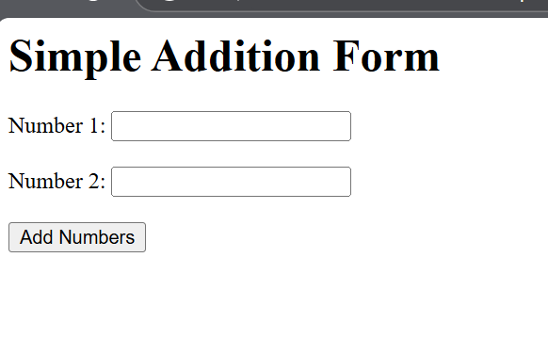

Question-28

Write a program in JavaScript to swap two images using on mouseover event.

Input:

<html>

<head>

<title>Swap Images on Mouseover</title>

<style>

img {

width: 300px; /* Set a fixed size for the images */

height: auto;

cursor: pointer;

transition: all 0.3s ease;

}

</style>

<script>

function swapImages() {

var image1 = document.getElementById('image1');

var image2 = document.getElementById('image2');

var tempSrc = image1.src;

image1.src = image2.src;

image2.src = tempSrc;

}

</script>

</head>

<body>

<h1>Swap Images on Mouseover</h1>

<img id="image1" src="https://via.placeholder.com/300x200.png?text=Image+1" alt="Image 1" onmouseover="swapImages()" />

<img id="image2" src="https://via.placeholder.com/300x200.png?text=Image+2" alt="Image 2" />

<p>Hover over the first image to swap them.</p>

</body>

</html>

Output:

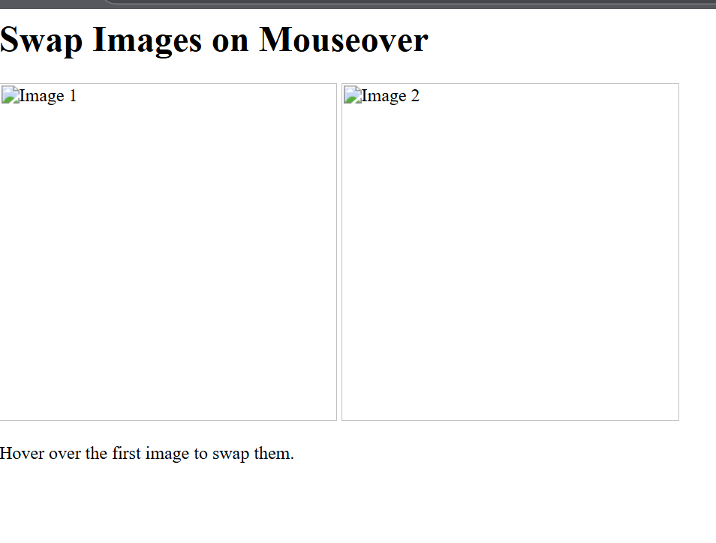

Question-29

Write a simple JavaScript program to sort an array

Input:

<html>

<head>

<title>Sort an Array in JavaScript</title>

<script>

function sortArray() {

var arr = [5, 3, 8, 1, 2, 7];

arr.sort(function(a, b) {

return a - b;

document.getElementById('result').innerHTML = "Sorted Array: " + arr;

}

</script>

</head>

<body>

<h1>Sort an Array in JavaScript</h1>

<button onclick="sortArray()">Sort Array</button>

<p id="result"></p>

</body>

</html>

Output:

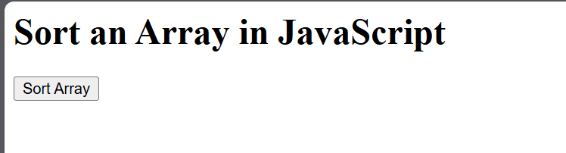

Question-30

Write a JavaScript program to take as input three numbers from the user. Find the minimum and maximum of the three numbers. Print the following output in BOLD in the following format:

MINIMUM =        MAXIMUM =

Input:

<html>

<head>

<title>Find Minimum and Maximum</title>

<script>

function findMinMax() {

var num1 = parseFloat(document.getElementById('num1').value);

var num2 = parseFloat(document.getElementById('num2').value);

var num3 = parseFloat(document.getElementById('num3').value);

var min = Math.min(num1, num2, num3);

var max = Math.max(num1, num2, num3);

document.getElementById('minOutput').innerHTML = "<b>MINIMUM = " + min + "</b>";

document.getElementById('maxOutput').innerHTML = "<b>MAXIMUM = " + max + "</b>";

}

</script>

</head>

<body>

<h1>Find Minimum and Maximum of Three Numbers</h1>

<label for="num1">Enter first number:</label>

<input type="number" id="num1" required><br><br>

<label for="num2">Enter second number:</label>

<input type="number" id="num2" required><br><br>

<label for="num3">Enter third number:</label>

<input type="number" id="num3" required><br><br>

<button onclick="findMinMax()">Find Min and Max</button>

<p id="minOutput"></p>

<p id="maxOutput"></p>

</body>

</html>

Output:

